Join in 4th Quarter

I wanted to welcome you to the Capital Vipers chapter of the Viper Owners Association.

I look forward to your involvement in helping grow our passion for the legendary Dodge Viper.

Your Member number is XXXX.

A couple of housekeeping items:

#1 When you log into the VOA Portal, you will need to sync the Portal with the Forum.  You will see that function on the "Members Portal" page on lower right side.

<https://driveviper.com/portal/>

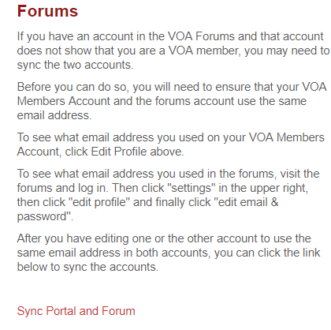

#2 The On-Boarding process will be accomplished over the next 4-6 weeks.

1. Day 1 Payment received

2. Day 2 Email sent to VOA Administrator to process (up to 72 hours)

3. Day 5 Email to “new” member with member number (normally filtered by provider or in “junk” folder)

4. Day 5 Email notice sent to Chapter President

**January 2nd 2020**

5. Day 1 New members from previous quarter reported as group

6. Day 2 National orders name badges (3-4 week delivery)

7. Day 30 National Administrator, Bridgett, processes welcome packets with badges and ordered items

8. Day 45 Welcome packets with any additional items mailed

9. **Magazine** is usually the quarter after joining and is based on distribution date.

Let me know if you have any question.  I have you on our official list so attending any Capital Viper events will not be an issue.

Please feel free to contact any of the Capital Viper team at any time.

Thank you for joining and participating on the Capital Vipers Facebook page.  We look forward to growing the chapter with you and for you.

See you on the road!!

Brian

(list officers and contact info)

Join Jan-Sept Quarter

I wanted to welcome you to the Capital Vipers chapter of the Viper Owners Association.

I look forward to your involvement in helping grow our passion for the legendary Dodge Viper.

Your Member number is **XXXX**.

A couple of housekeeping items:

#1 When you log into the VOA Portal, you will need to sync the Portal with the Forum.  You will see that function on the "Members Portal" page on lower right side.



#2 The On-Boarding process will be accomplished over the next 4-6 weeks.

1. Day 1 Payment received

2. Day 2 Email sent to VOA Administrator to process (up to 72 hours)

3. Day 5 Email to “new” member with member number (normally filtered by provider or in “junk” folder)

4. Day 5 Email notice sent to Chapter President

NEXT Calendar Month after Joining

5. Day 1 New members from previous month reported as group

6. Day 2 National orders name badges (2-3 week delivery)

7. Day 21 National Administrator, Bridgett, processes welcome packets with badges and ordered items

8. Day 26 Welcome packets with any additional items mailed

9. Magazine is usually the quarter after joining and is based on distribution date.

Let me know if you have any question.

Please feel free to contact any of the Capital Viper team at any time.

If you haven't already, then please join the Capital Vipers at <https://www.facebook.com/groups/444996869273482/>

See you on the road!!

Brian

(list officers and contact info)